Day 3 : Statistical analysis using R
Session 9: Descriptive statistics and hypothesis testing
  - Descriptive statistics
E031-descriptive_statistics.R
data(mtcars) #from datasets package

vars <- c('mpg','cyl','disp')

#basic descriptive statistics from base package
summary(mtcars[vars])
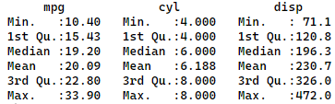

#descriptive statistics from other packages
Hmisc::describe(mtcars[vars])
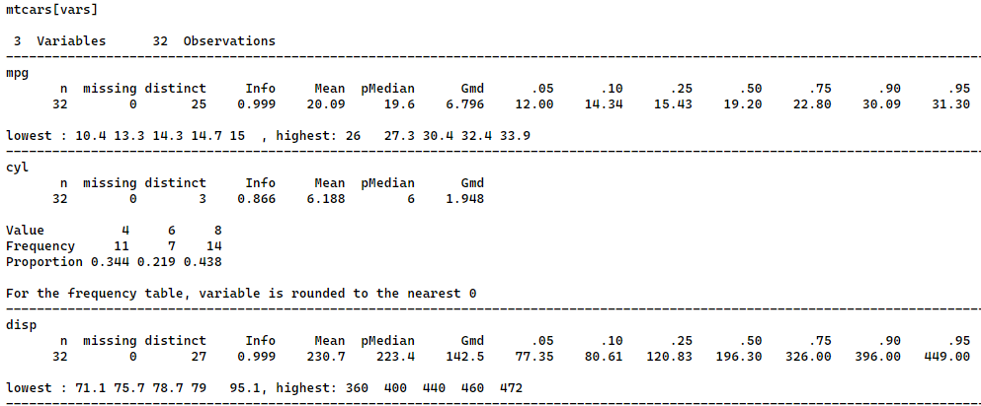

pastecs::stat.desc(mtcars[vars])
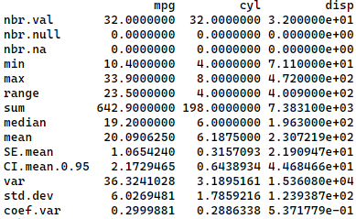

psych::describe(mtcars[vars])

#----------------------------------
# Descriptive statistics by group
#----------------------------------
#grouping by one variable
by(mtcars[vars], #dataset
list(Transmission = mtcars$am), #grouping variable: Transmission (0 = automatic, 1 = manual)
summary) #function
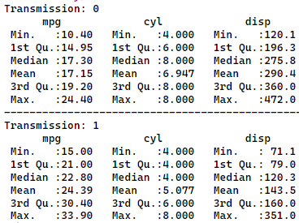

#grouping by multiple variables
by(mtcars[vars],
list(Transmission = mtcars$am, Engine = mtcars$vs), # Transmission (0 = automatic, 1 = manual), Engine (0 = V-shaped, 1 = straight)
summary)
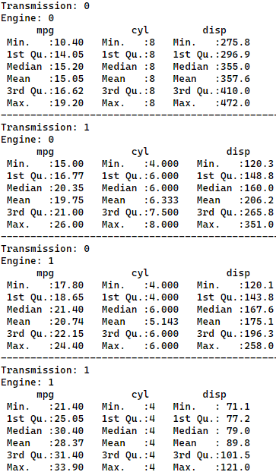

  - The concept of normal distribution
- What is a Normal Distribution?
- Shape: The normal distribution looks like a bell-shaped curve.
- Symmetry: It is perfectly symmetrical around the center.
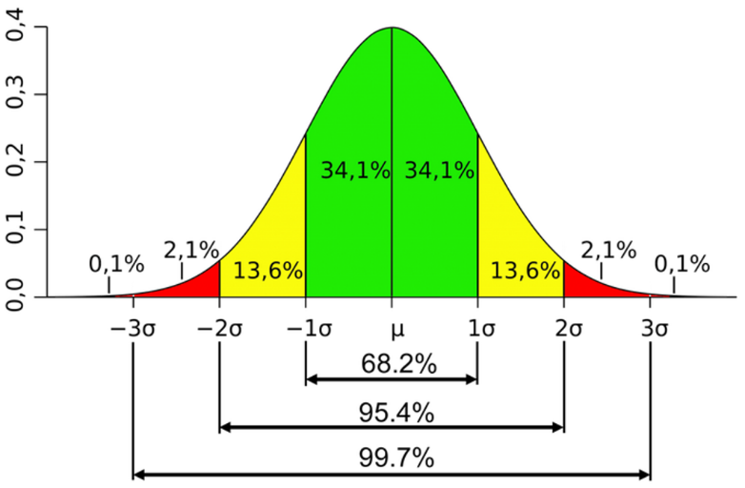
- Key Characteristics:
- Mean (Average): The center of the curve.
- Standard Deviation: Measures the spread of the data.
  - 68.2% of the data falls within 1 standard deviation of the mean.
  - 95.4% falls within 2 standard deviations.
  - 99.7% falls within 3 standard deviations.
- Why is it Important?
- Natural Occurrences: Many natural phenomena follow this distribution (e.g., heights, test scores). For example, most students score around the average in a class, fewer scoring very high or very low.
- Central Limit Theorem: In large samples, the samples’ mean tend to be normally distributed. (Video)
- Statistical Inferences: Helps in making predictions and decisions based on data.
  - Hypothesis testing
- What is Hypothesis Testing?
- Hypothesis testing is a method used to decide whether there is enough evidence to support a particular claim about a population based on a sample of data.
- Null Hypothesis (H₀): This is the default statement that there is no effect or no difference. It assumes that any observed differences are due to random chance.
Example: "The average age is equal to 20."
- Alternative Hypothesis (H₁): This is what you want to prove, stating there is an effect or a difference.
Example: "The average age is not equal to 20."
- Procedure of hypothesis testing
- State the null and alternative hypothesis. (e.g. $H_{0}: μ=0$, $H_{1}: μ≠0$)
- Collect sample data.
- Calculate sample mean and stadard error ($\frac{s}{\sqrt{n}}$).
- Calculate t-statistics ($t =\frac{\overline{X}-μ}{Standar Error}$ ).
- Compare absolute value of t-statistics |t| with critical values for given level of significance ($α$). [1.65 (10% significance level), 1.96 (5%), 2.58 (1%)]
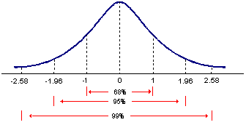
- Decision: reject null hypothesis if |t| exceeds critical value, otherwise fail to reject null hypothesis.

- Hypothesis testing with p-value
- p-value : probability (area under normal distribution) beyond |t| i.e., probability of rejecting H₀ when its true.
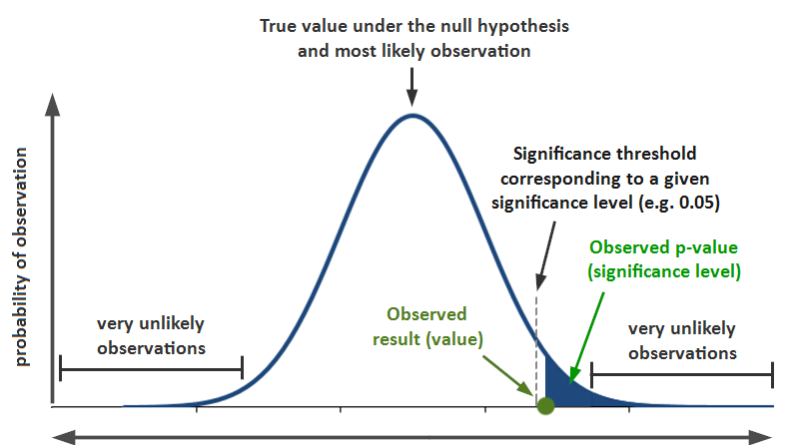
- Decision : reject null hypothesis if p-value is lower than the significance level, otherwise fail to reject null hypothesis.
- Easier to conduct hypothesis testing with p-value. No need to calculate t-statistics and remember different critical values.
E033-hypothesis_testing.R
library(dplyr)

# Set seed for reproducibility
set.seed(12345)

# Create a dummy dataset
n <- 1000
group <- rep(0:1, length.out = n)
score <- 50 + group * 10 + rnorm(n, mean = 0, sd = 10)

# Combine into a data frame
data <- data.frame(group = group, score = score)

# Conducting hypothesis testing (one-sample t-tests)
t.test(data$score, mu = 50) # H0: pop_mean = 50
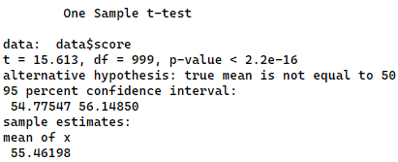

t.test(data$score, mu = 55) # H0: pop_mean = 55
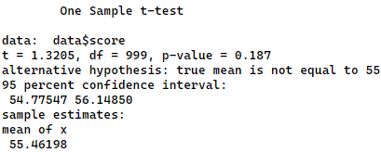

t.test(data$score, mu = 60) # H0: pop_mean = 60
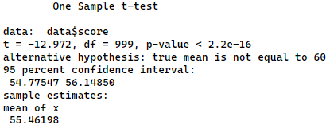

# --------------------------------------
# Conducting two-sample t-test
# --------------------------------------
data0 <- filter(data, group == 0)
data1 <- filter(data, group == 1)
t.test(data0$score, data1$score)
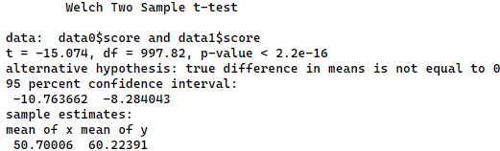

#OR

t.test(score ~ group, data = data) # H0: pop_mean_group1 = pop_mean_group2
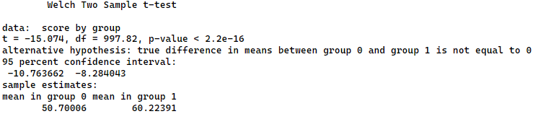

Task 7:
Using NMICS6 data (009-hl.sav), conduct a hypothesis test whether average age between male and female is statistically different.
# Load necessary libraries
library(haven) # For reading SPSS files
library(dplyr)

# Import SPSS file from the URL
df <- read_spss('data/009-hl.sav')

# HL6 -> Age, HL4 -> Sex
# Summarize age for males (HL4 == 1) and females (HL4 == 2)
df_male <- filter(df, HL4 == 1)
df_female <- filter(df, HL4 == 2)
mean(df_male$HL6)
mean(df_female$HL6)
#OR
by(df$HL6, df$HL4, summary) #average age : male = 28.26, female = 28.83

# Conduct hypothesis testing (two-sample t-test)
t.test(HL6 ~ HL4, data = df)
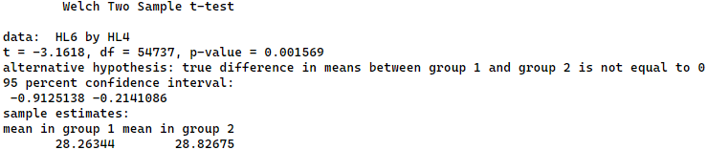

# Alternatively, use linear regression
regression_result <- lm(HL6 ~ HL4, data = df)
summary(regression_result)
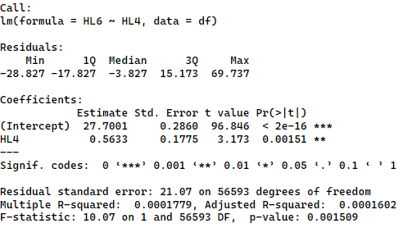

Session 10: Regression
10.1 Fitting regression models with lm()
Symbols commonly used in R formulas
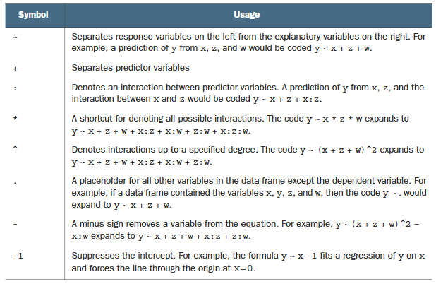
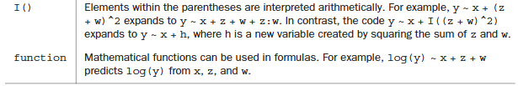
E034-simple_regression.R
# Set seed for reproducibility
set.seed(12345)

# Generate 1000 observations
n <- 1000

# Generate study_hours as uniform random numbers between 0 and 10
study_hours <- round(runif(n, min = 0, max = 10))

# Generate score as a linear function of study_hours with noise
score <- 50 + 5 * study_hours + rnorm(n, mean = 0, sd = 5)

# Combine into a data frame
df <- data.frame(study_hours, score)

# Perform linear regression
model <- lm(score ~ study_hours, data = df)

# Summarize the regression results
summary(model)
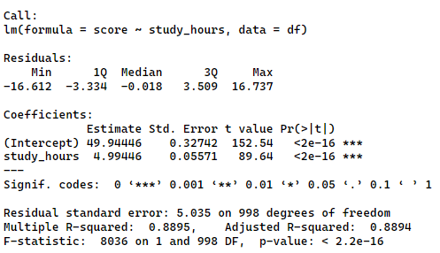

# visualizing simple regression
library(ggplot2)
ggplot(data = df, aes(x=study_hours, y=score)) +
geom_point() +
geom_smooth(method = 'lm') +
theme_bw()
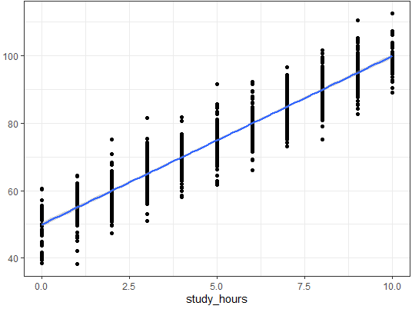

  - Multiple regression

E035-multiple_regression.R
# Set seed for reproducibility
set.seed(12345)

# Generate 200 observations
n <- 200

# Generate age variable (cycles from 18 to 69)
age <- (1:n %% 52) + 18

# Generate educ_year variable (cycles from 0 to 17)
educ_year <- (1:n %% 18)

# Generate income variable with a linear relationship to age and educ_year, plus noise
income <- 20000 + 800 * age + 3000 * educ_year + rnorm(n, mean = 0, sd = 2000)

# Combine into a data frame
df <- data.frame(age, educ_year, income)

# Regression with omitted variable
model_omitted <- lm(income ~ age, data = df)
summary(model_omitted)
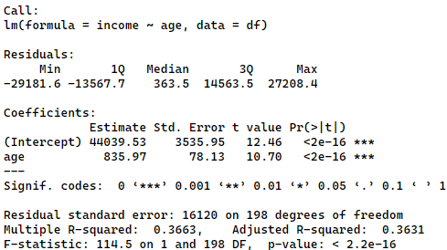

# Residual diagnostics for omitted variable model
plot(model_omitted, which = 1) # Residual vs Fitted plot
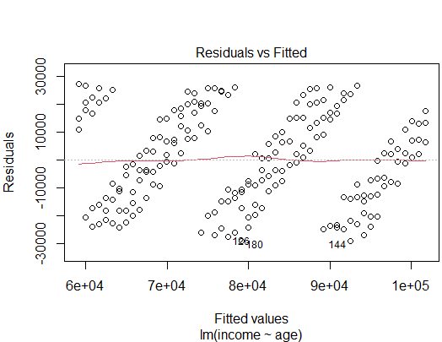

resid_omitted <- residuals(model_omitted)
hist(resid_omitted)
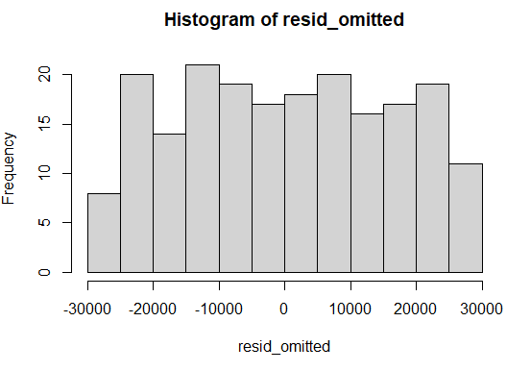

shapiro.test(resid_omitted) # Shapiro-Wilk test for normality [H0: normally distributed]
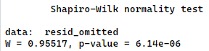

#---------------------------------------------------------------------------
# Multiple regression with correct specification
model_correct <- lm(income ~ age + educ_year, data = df)
summary(model_correct)
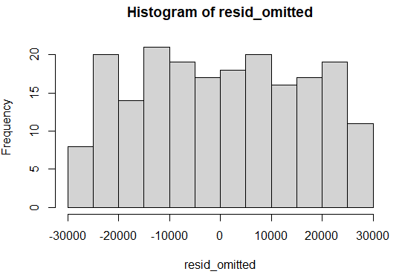

# Residual diagnostics for correctly specified model
plot(model_correct, which = 1) # Residual vs Fitted plot
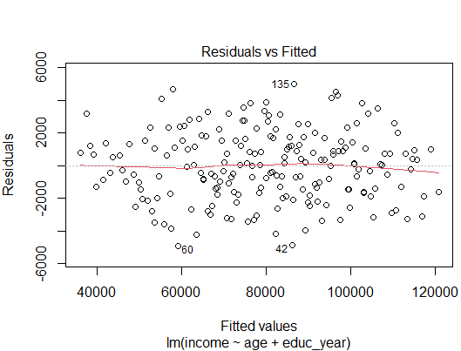
resid_correct <- residuals(model_correct)
hist(resid_correct)
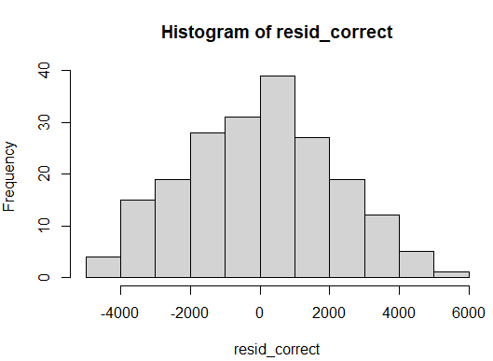
shapiro.test(resid_correct) # Shapiro-Wilk test for normality
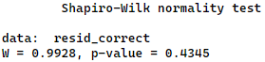

  - Polynomial regression

E036-polynomial_regression.R
library(ggplot2)

mtcars <- datasets::mtcars

#--------------------------------------
#simple regression
#--------------------------------------
fit <- lm(data = mtcars, formula = mpg ~ hp) # mpg: Miles/(US) gallon, hp: Gross horsepower
summary(fit) #R-squared : 0.6024, Residual standard error: 3.863
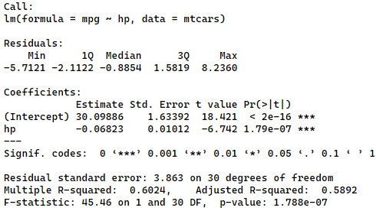

ggplot(mtcars, aes(x = hp, y = mpg)) +
geom_point() +
stat_smooth(method = 'lm', formula = y ~ x, color = 'red', se = FALSE) +
theme_bw()
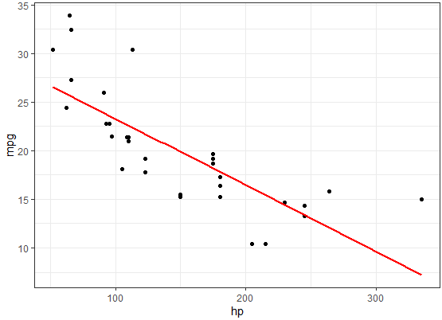

#--------------------------------------
#Polynomial regression regression
#--------------------------------------
fit <- lm(data = mtcars, formula = mpg ~ hp + I(hp^2))
summary(fit) #R-squared : 0.7561, Residual standard error: 3.077
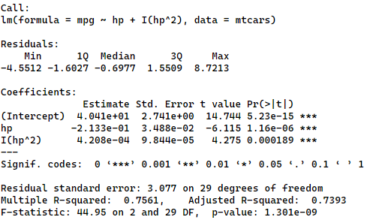

ggplot(mtcars, aes(x = hp, y = mpg)) +
geom_point() +
stat_smooth(method = 'lm', formula = y ~ x + I(x^2), color = 'red', se = FALSE) +
theme_bw()
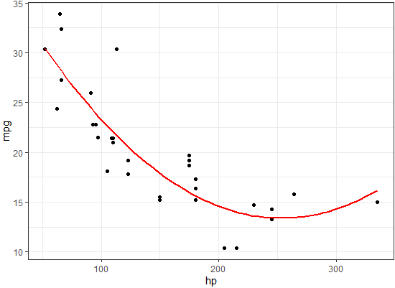

  - Regression with interaction term

E037-regression_with_interaction.R
mtcars <- datasets::mtcars

#generating a new interaction term hp * wt
mtcars$hp_wt <- mtcars$hp * mtcars$wt

fit <- lm(mpg ~ hp + wt + hp_wt, data=mtcars)
summary(fit)

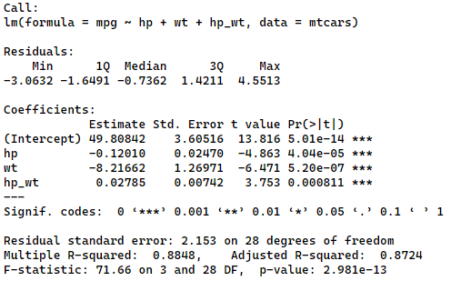
#OR

fit <- lm(mpg ~ hp + wt + hp:wt, data=mtcars)
summary(fit)

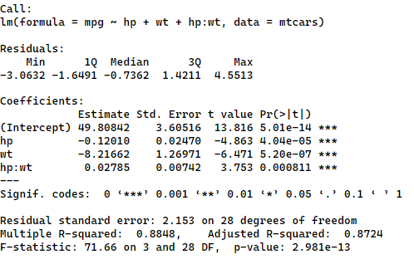
#* -------------------------------------------------------------
#* A significant coefficient of interaction term indicates that
#* the relationship between mpg and hp varies by wt. Similarly,
#* the relationship between mpg and wt varies by hp.
#* -------------------------------------------------------------

# d(mpg)/d(hp) = - 0.12010 + 0.02785 * wt
wt = 1
print(- 0.12010 + 0.02785 * wt) #-0.09225

wt = 2
print(- 0.12010 + 0.02785 * wt) #-0.0644

wt = 3
print(- 0.12010 + 0.02785 * wt) #-0.03655

# d(mpg)/d(wt) = - 8.21662 + 0.02785 * hp
hp = 100
print(- 8.21662 + 0.02785 * hp) #-5.43162

hp = 150
print(- 8.21662 + 0.02785 * hp) #-4.03912

hp = 200
print(- 8.21662 + 0.02785 * hp) #-2.64662

  - Logarithmic regression

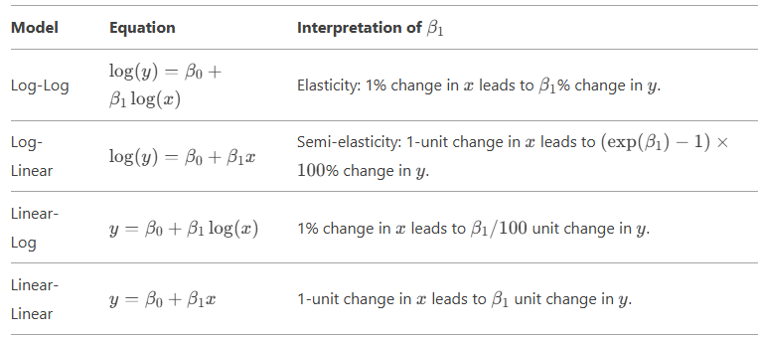

E038-logarithmic_regression.R
#----------------------------------------------------------
# Log-Log Regression
#----------------------------------------------------------
# Load data
mtcars <- datasets::mtcars

# Log-log regression
model_loglog <- lm(log(mpg) ~ log(disp), data = mtcars)
summary(model_loglog)
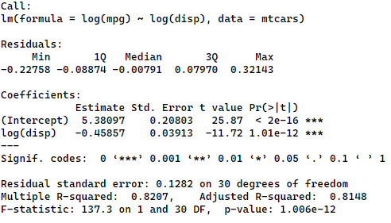

# A 1% increase in Displacement (cu.in.) reduces Miles/(US) gallon by ~0.46%.

#----------------------------------------------------------
# Log-Linear Regression
#----------------------------------------------------------
# Log-linear regression
model_loglin <- lm(log(mpg) ~ hp, data = mtcars)
summary(model_loglin)
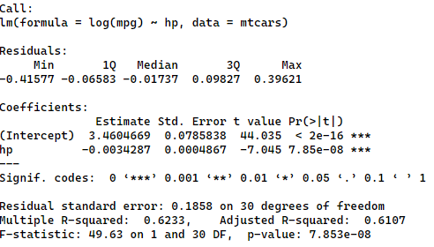
# A 1-unit increase in horsepower reduces MPG by ~0.34% (exp(-0.0034287) - 1 ≈ -0.003422829).

#----------------------------------------------------------
# Linear-Log Regression
#----------------------------------------------------------
# Load data
trees <- datasets::trees

# Linear-log regression
model_linlog <- lm(Volume ~ log(Girth), data = trees)
summary(model_linlog)
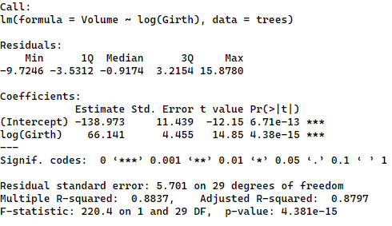
# A 1% increase in girth increases volume by ~ 0.66 units (66.141 / 100).

Session 11: Logistic regression
  - Logistic regression
Logistic regression is useful when you’re predicting a binary outcome from a set of
continuous and/or categorical predictor variables.
E039-logistic_regression.R
# Load necessary libraries
library(haven) # For reading SPSS files
library(dplyr) # For data manipulation
library(margins) # For calculating marginal effects

# Import SPSS file from the URL
data <- read_spss('data/010-hh.sav')

# Dropping missing values in HHSEX
data <- data %>% filter(!is.na(HHSEX))

# Creating new variables
data <- data %>%
mutate(
hh_size = HH48, # HH member size variable
urb_rur = factor(HH6), # 1=Urban 2=Rural
province = factor(HH7), # Province number
hhsex = factor(HHSEX) # 1=Male 2=Female
)

#setting 1=Urban as reference/base
data$urb_rur <- relevel(data$urb_rur, ref = '1')

#setting 2=Female as reference/base
data$hhsex <- relevel(data$hhsex, ref = '2')

#setting province 3 as base category/reference level
data$province <- relevel(data$province, ref = '3')

#-----------------------------------------------
# Running logistic regression
#-----------------------------------------------
logit_model <- glm(hhsex ~ hh_size + urb_rur + province,
data = data, family = binomial(link = "logit"))
summary(logit_model)
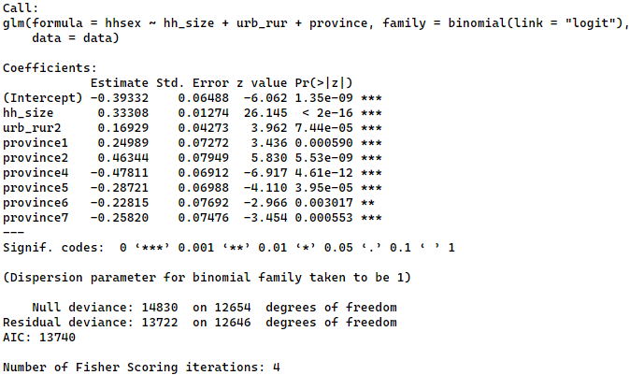

# Calculating marginal effects for logistic regression
logit_margins <- margins(logit_model)
summary(logit_margins)
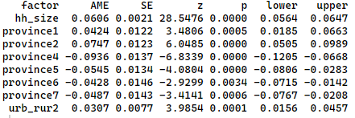

#-----------------------------------------------
# Running probit regression
#-----------------------------------------------
probit_model <- glm(hhsex ~ hh_size + urb_rur + province,
data = data, family = binomial(link = "probit"))
summary(probit_model)
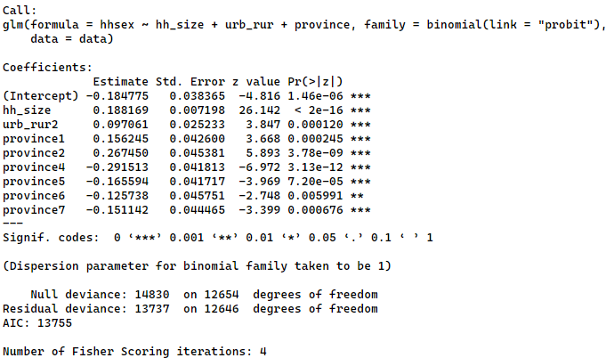

# Calculating marginal effects for probit regression
probit_margins <- margins(probit_model)
summary(probit_margins)
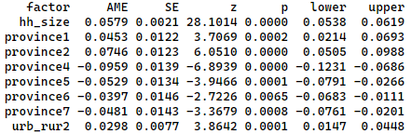

Task 8:
Using NMICS6 data (011-Affairs.RData), complete the following tasks.
- Load the 011-Affairs.RData
- Tabulate the frequency of affairs variable from Affairs dataframe.
- Create a variable ynaffairs in Affairs dataframe such that the variable takes value 0 if no affairs and 1 if the person is involved in affairs.
- Set ynaffairs and rating variables as factor variables.
- Set ‘0’ as reference for ynaffairs variable, ‘5’ for rating, ‘no’ for children, and ‘female’ for gender variables.
- Fit a logistic regression model with ynaffairs as dependent variable and gender, age, yearsmarried, children, rating as independent variable.
- Calculate average marginal effect for each variables using the margins() function.

library(dplyr)
library(margins)

load('data/011-Affairs.RData')
table(Affairs$affairs)
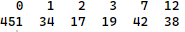

Affairs <- Affairs %>% mutate(ynaffair = case_when(affairs > 0 ~ 1, TRUE ~ 0),
ynaffair = factor(ynaffair),
rating = factor(rating))
table(Affairs$ynaffair)
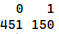

#setting 0 : No-Affairs as base/reference
Affairs$ynaffair <- relevel(Affairs$ynaffair, ref = '0')

#setting 5 : Very happy as base/reference
# 1 = very unhappy, 2 = somewhat unhappy, 3 = average, 4 = happier than average, 5 = very happy.
Affairs$rating <- relevel(Affairs$rating, ref = '5')

#setting no children as base/reference
Affairs$children <- relevel(Affairs$children, ref = 'no')

#setting female as base/reference
Affairs$gender <- relevel(Affairs$gender, ref = 'female')

fit <- glm(ynaffair ~ gender
+ age
+ yearsmarried
+ children
+ rating,
data=Affairs,
family = binomial(link = "logit"))

summary(fit)
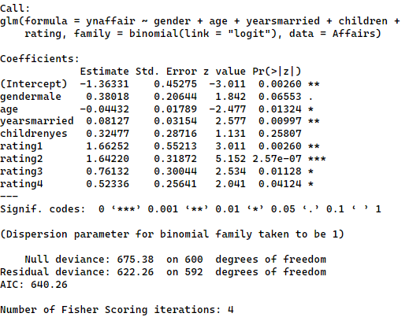

summary(margins(fit))
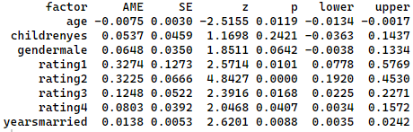

Session 12: R notebook with R-markdown

Session 11: Time-series analysis
  - Stationarity concept
- Stationarity refers to a time series whose statistical properties, such as mean, variance, and autocorrelation, remain constant over time.
- Non-stationary series are prone to spurious relationships.

  - Spurious relationships
E040-spurious_regression.R
library(haven)
library(dplyr)
library(tseries)
library(ggplot2)

df <- read_dta('data/012-pwt1001.dta')

#keeping real GDP of Nepal from 1960 onwards
npl <- df %>%
filter(countrycode == 'NPL' & year >= 1960) %>%
select(year, rgdpe) %>%
rename(rgdpe_npl = rgdpe)

#keeping real GDP of USA from 1960 onwards
usa <- df %>%
filter(countrycode == 'USA' & year >= 1960) %>%
select(year, rgdpe) %>%
rename(rgdpe_usa = rgdpe)

#joining Nepal and USA data into one dataframe
df_npl_usa <- full_join(npl, usa, by = 'year')

#Visual inspection of stationarity
ggplot() +
geom_line(data = df_npl_usa, aes(x=year, y=rgdpe_npl), size = 1) +
labs(title = 'Nepal GDP') +
theme_bw()
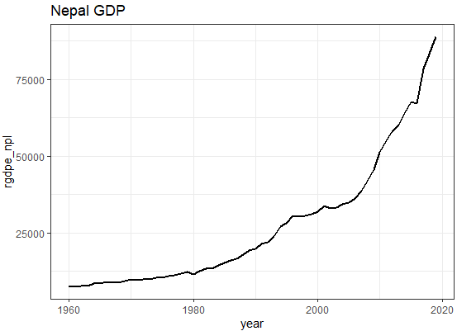

ggplot() +
geom_line(data = df_npl_usa, aes(x=year, y=rgdpe_usa), size = 1) +
labs(title = 'USA GDP') +
theme_bw()
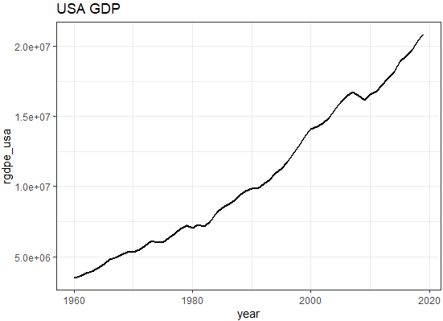

#Hypothesis testing of stationarity
adf.test(df_npl_usa$rgdpe_npl)
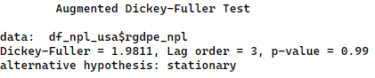

adf.test(df_npl_usa$rgdpe_usa)
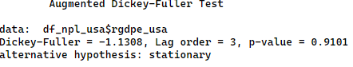

#Running a regression (Spurious regression observed)
fit <- lm(formula = rgdpe_usa ~ rgdpe_npl ,data = df_npl_usa)
summary(fit)
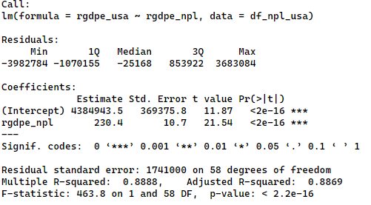

#-------------------------------------------------------------
# Making series stationary and repeating the above steps
#-------------------------------------------------------------
df_npl_usa <- df_npl_usa %>%
mutate(dlrgdpe_npl = c(NA,diff(log(rgdpe_npl))),
dlrgdpe_usa = c(NA,diff(log(rgdpe_usa)))) %>%
na.omit()

#Visual inspection of stationarity
ggplot() +
geom_line(data = df_npl_usa, aes(x=year, y=dlrgdpe_npl), size = 1) +
labs(title = 'Nepal GDP growth') +
theme_bw()
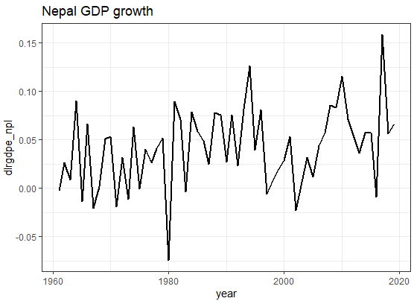

ggplot() +
geom_line(data = df_npl_usa, aes(x=year, y=dlrgdpe_usa), size = 1) +
labs(title = 'USA GDP growth') +
theme_bw()
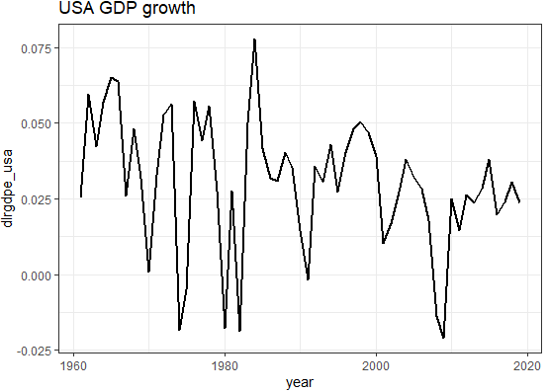

#Hypothesis testing of stationarity
adf.test(df_npl_usa$dlrgdpe_npl)
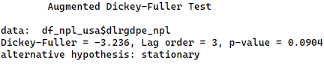

adf.test(df_npl_usa$dlrgdpe_usa)
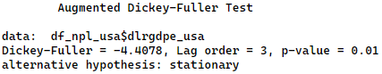

#Running a regression (no spurious regression observed)
fit <- lm(formula = dlrgdpe_usa ~ dlrgdpe_npl ,data = df_npl_usa)
summary(fit)
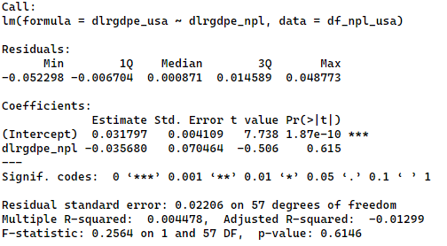

  - True relationships
E041-actual_relationship.R
library(haven)
library(dplyr)
library(tseries)
library(ggplot2)

df <- read_dta('data/012-pwt1001.dta')

df <- filter(df, countrycode == 'NPL' & year >= 1960) %>% select(year, rgdpe, ccon)

#Visual inspection of stationarity
ggplot() +
geom_line(data = df, aes(x=year, y=rgdpe), size = 1) +
labs(title = 'Nepal GDP') +
theme_bw()

ggplot() +
geom_line(data = df, aes(x=year, y=ccon), size = 1) +
labs(title = 'Nepal Consumption (Private + Govt)') +
theme_bw()
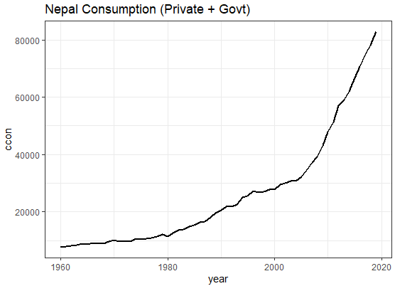

#Hypothesis testing of stationarity
adf.test(df$rgdpe)
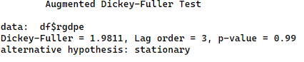

adf.test(df$ccon)
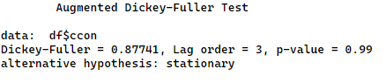

#Running a regression
fit <- lm(formula = rgdpe ~ ccon ,data = df)
summary(fit)
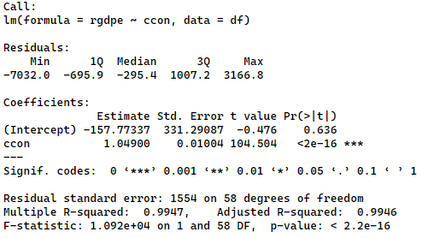
#-------------------------------------------------------------
# Making series stationary and repeating the above steps
#-------------------------------------------------------------
df <- df %>%
mutate(dlrgdpe = c(NA,diff(log(rgdpe))),
dlccon = c(NA,diff(log(ccon)))) %>%
na.omit()

#Visual inspection of stationarity
ggplot() +
geom_line(data = df, aes(x=year, y=dlrgdpe), size = 1) +
labs(title = 'Nepal GDP growth') +
theme_bw()
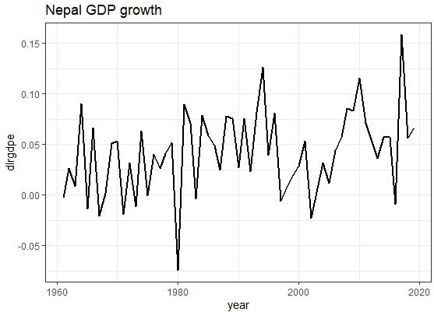

ggplot() +
geom_line(data = df, aes(x=year, y=dlccon), size = 1) +
labs(title = 'Nepal Consumption (Private + Govt) growth') +
theme_bw()
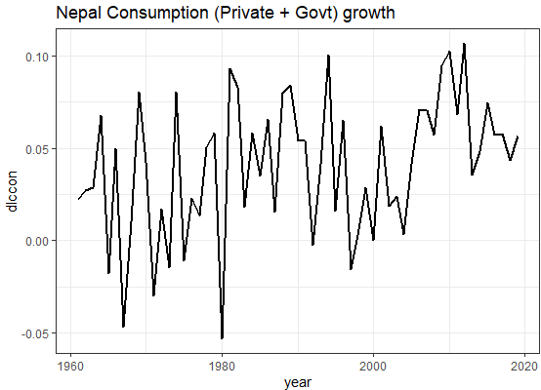

#Hypothesis testing of stationarity
adf.test(df_npl_usa$dlrgdpe_npl)
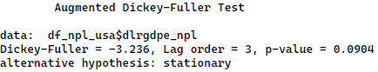

adf.test(df_npl_usa$dlrgdpe_usa)
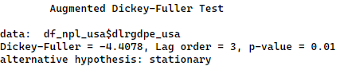

#Running a regression
fit <- lm(formula = dlrgdpe ~ dlccon ,data = df)
summary(fit)
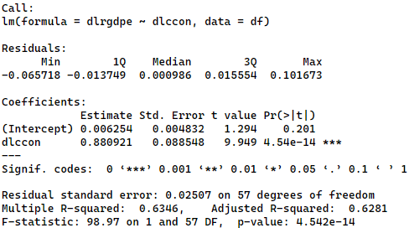

Session 12: Stargazer for reporting regression results and the project work
  - stargazer
E042-stargazer.R
mtcars <- datasets::mtcars

model1 <- lm(mpg ~ hp, data = mtcars)
model2 <- lm(mpg ~ hp + drat, data = mtcars)
model3 <- lm(mpg ~ hp + drat + cyl + wt, data = mtcars)
model4 <- lm(hp ~ disp + carb, data = mtcars)

library(stargazer)

#descriptive statistics table
stargazer(mtcars, type = 'text')
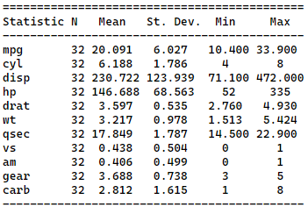

#displaying regression models results in a single table
stargazer(model1, model2, model3, model4, type = "text")
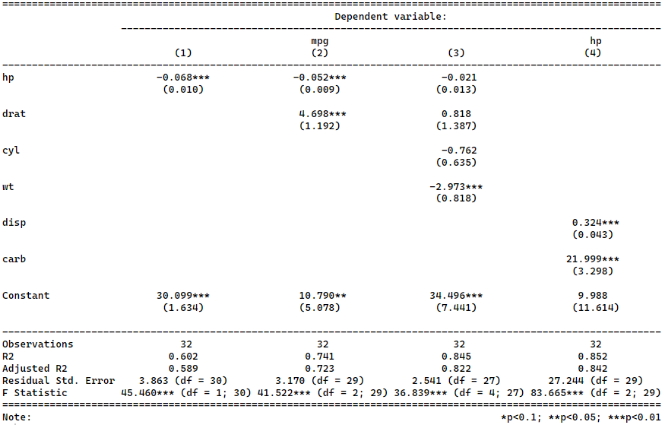

#defining the covariate and variable labels
stargazer(model1, model2, model3, model4, type = "text",
digits = 2,
covariate.labels = c('Gross horsepower (hp)',
'Rear axle ratio (dart)',
'Number of cylinders (cyl)',
'Weight (1000 lbs) (wt)',
'Displacement (cu.in.) (disp)',
'Number of carburetors (carb)'),
dep.var.labels = c("Miles/(US) gallon (mpg)", "Gross horsepower (hp)"),
notes = "Standard errors are in parentheses.")

#export and save the result as html
stargazer(model1, model2, model3, model4, type = "html", out = 'model_results.html',
digits = 2,
covariate.labels = c('Gross horsepower (hp)',
'Rear axle ratio (dart)',
'Number of cylinders (cyl)',
'Weight (1000 lbs) (wt)',
'Displacement (cu.in.) (disp)',
'Number of carburetors (carb)'),
dep.var.labels = c("Miles/(US) gallon (mpg)", "Gross horsepower (hp)"),
notes = "Standard errors are in parentheses.")
